Technical Proposal
Coca-Cola × FIFA World Cup 2026
Under-the-Cap Promotion
Digital Platform (UTC Platform)

Based on: “FIFA UTC Platform Brief”

Prepared on: 02 March 2026

1. Executive Summary
This proposal describes a secure, mobile-first, gamified web platform to support the Coca-Cola × FIFA World Cup 2026 Under-the-Cap (UTC) promotion. The solution enables QR-led onboarding, OTP-based verification, single-use code validation, quiz participation, instant cashback calculation and payout orchestration, points accumulation, reward catalog and redemption, a live leaderboard for the grand prize selection, and a separate collection-center verification and stock management module.

2. Understanding of the Brief and Scope

2.1 Campaign Overview
Campaign kickoff | 1 April 2026
Winner selection date | 15 May 2026
Campaign end date | 30 June 2026
Promo products | Coca-Cola 1.75L & 2L (promo packs only)
Entry mechanism | QR-led journey + 7-digit under-the-cap unique code
Rewards | Instant cashback per correct quiz answer; FIFA merchandise via points; FIFA trip for top leaderboard winners

2.2 Core User Journey
- Scan QR on label → mobile landing page (campaign explanation and CTA).
- Registration and consent → OTP verification (mandatory) with phone number.
- Enter under-the-cap unique code → validate single use and eligibility.
- Receive 1 quiz question → capture answer and evaluate.
- If correct → determine cashback amount (৳5–৳100) and show confirmation + payout messaging.
- Update points → show dashboard (points, cashback, progress, leaderboard rank).
- Redeem merchandise → generate redemption ID/QR and direct to nearest collection center.
- Collection-center manager validates pickup and inventory is deducted in real time.

2.3 Platform Modules
- Consumer Web Experience (mobile-first website / PWA)
- Campaign CMS (content, FAQs, T&Cs updates)
- Rewards & Redemption Engine (points, catalog, stock, eligibility)
- Cashback Engine and Payout Orchestration (integration ready)
- Leaderboard Engine (fairness safeguards + anti-fraud)
- Collection Center Portal (verification + stock management)
- Admin Console (campaign operations, users, reporting, audit)
- Observability & Analytics (dashboards, logs, alerts)

3. Proposed Technical Approach

3.1 Solution Principles
- Mobile-first and low-bandwidth optimized (fast initial load, compressed assets, CDN, caching).
- Security by design (OTP hygiene, rate limiting, tamper-proof code handling, audit trails).
- Fair and resilient gamification (leaderboard integrity, fraud prevention, duplicate blocking).
- Highly available and scalable during campaign peaks.
- Configurable campaign operations without frequent redeployments (admin configuration).

3.2 Functional Design (high-level)
- Code validation service enforces single use and anti-bruteforce protections.
- Quiz service delivers randomized football questions; answers evaluated server-side.
- Cashback rules engine selects reward amounts per correct answer and triggers payout workflow.
- Points service tracks accumulation and thresholds; redemption generates a unique redemption token/QR.
- Inventory service maintains real-time stock per collection center and item category.
- Leaderboard service ranks users by points with safeguards (anti-scripting, anomaly detection, tie rules).

4. Proposed System Architecture
Figure 1: High-Level System Architecture

Figure 2: End-to-End Consumer Journey Flow
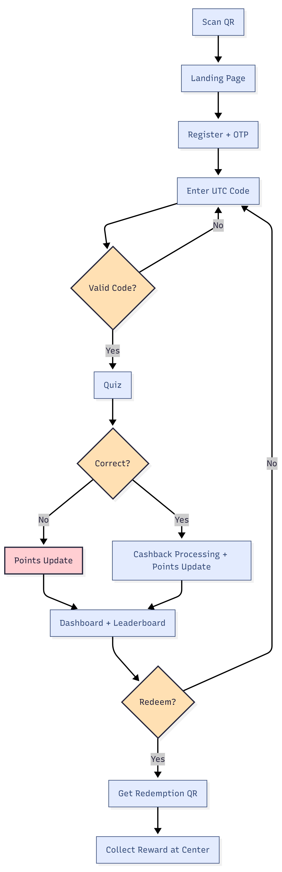

Figure 3: Redemption Verification & Stock Deduction Flow
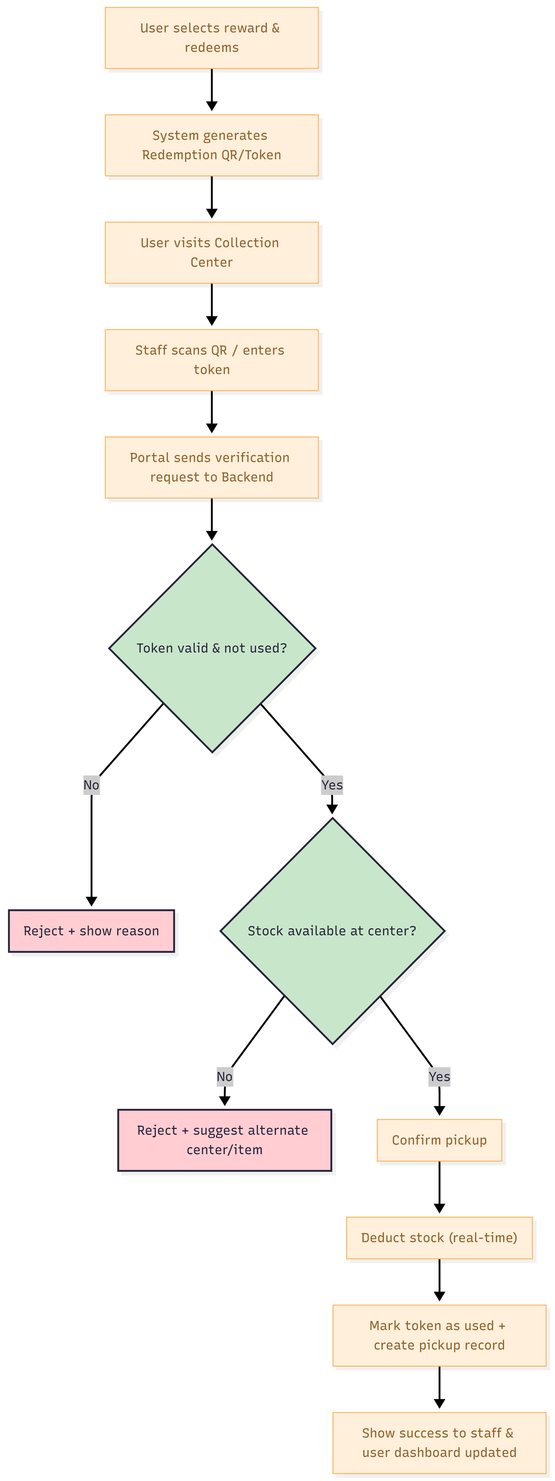

5. Key Workflows and Controls

5.1 Under-the-Cap Code Validation
- Codes are generated in advance and loaded securely (hashed at rest, never exposed in bulk).
- Each code is single-use; validation includes status (unused/used/invalid), product type, and campaign dates.
- Anti-bruteforce controls: rate limiting per IP/device/user; progressive delays; bot detection.
- Idempotent handling to prevent double awarding from retries/timeouts.

5.2 OTP Registration & Account Controls
- OTP is mandatory for participation; OTP TTL and attempt limits enforced.
- OTP values are never logged; server stores only hashed/derived OTP state.

5.3 Leaderboard Fairness Safeguards
- Server-side scoring only; no client-side point computation.
- Abuse detection: unusually high velocity of code entries, repeated failed codes, automation patterns.
- Tie-break rules defined (e.g., earliest to reach points, or randomized under audit).
- Full audit trail for winner verification and dispute handling.

5.4 Rewards Redemption and Collection Center Verification
- User redeems an item when threshold is met; system issues a redemption token/QR with expiry.
- Collection center portal validates token/phone and confirms pickup via OTP or digital signature.
- Real-time stock deduction; duplicate prevention; low-stock alerts and reconciliation reports.

5.5 Cashback Payout Orchestration
- Cashback amount determined by rules engine; payout workflow executed asynchronously via queue.
- Integrates with selected payment rails (e.g., MFS payout APIs, bank transfer, or voucher).
- Idempotent payout with unique transaction reference; automated retries; manual review queue for failures.
- User-facing cashback status page shows lifecycle: Pending → Processing → Paid/Failed (with support path).

6. Proposed Technical Stack

6.1 Recommended Stack (modifiable to client standards)
Layer | Recommended Technology Options | Notes
Frontend | Next.js (React) + TypeScript, Tailwind CSS | SEO-friendly, performant, PWA-ready, componentized UI
Backend | Laravel | Strong API structure; supports validation, queues, and integrations
Database | MySQL | Relational integrity for codes, points, inventory, redemptions
Cache | Redis | Leaderboards, sessions, rate limiting, hot catalogs
Queue/Workers | RabbitMQ or SQS + workers | Async payout, notifications, reporting jobs
Object Storage | S3-compatible (AWS S3 / Azure Blob) | Static assets, exports, audit artifacts
Infrastructure | Docker + Kubernetes (or managed container service) | Scalable deployment; blue-green/rolling updates
Security | WAF, secrets manager, TLS everywhere | Hardening baseline + secure secret storage
CI/CD | GitHub Actions / GitLab CI | Automated build, test, scan, deploy

6.2 Integrations
- OTP Provider: SMS gateway (local aggregator) with delivery reports and failover routing.
- Cashback Payout: MFS payout/disbursement API or alternative payment processor.
- Email/SMS Notifications: transactional messaging for OTP, redemption, payout updates.
- Analytics: event tracking (server-side + client-side) with privacy-safe consent.

7. Data Model (High-Level)
- User, UserProfile (division, district, DOB), Consent
- OtpSession, AuthSession
- PromoCode (hashed), CodeRedemptionAttempt, CodeUsage
- QuizQuestion, QuizAttempt, CashbackAward
- PointsLedger, RewardItem, RewardStock (by center), RedemptionOrder, RedemptionToken
- CollectionCenter, BoothManager, PickupConfirmation
- LeaderboardSnapshot, FraudFlag, AuditLog

8. Development Methodology

8.1 Delivery Model
- Agile delivery with sprints and stakeholder checkpoints.
- Early POC slice: QR → registration/OTP → code validation → quiz → points → basic dashboard.
- Incremental rollout: leaderboard, rewards catalog, redemption + collection center portal, payouts integration.
- Hardening sprint(s): performance tuning, security testing, failover drills, operational readiness.

9. Testing and Quality Assurance

9.1 QA Strategy
- Test pyramid: Functional tests (services/rules) + integration tests (API, DB) + end-to-end tests (critical flows).
- Security testing aligned with OWASP ASVS and OWASP API Security Top 10.
- Performance testing: load, stress, and soak tests around expected campaign spikes.
- Compatibility testing: major Android/iOS browsers and low-memory devices; 3G/low bandwidth simulations.
- Operational readiness: monitoring, alert thresholds, backup/restore and disaster recovery drills.

Fig: QA Test Process

10. Deliverables
Category | Deliverables
Product & UX | UX/UI design assets and clickable prototype; content structure; responsive UI implementation
Consumer Platform | Landing + How to Play + Registration/OTP + Code Entry/Quiz + Dashboard + Rewards + Cashback Status + Leaderboard + FAQ/T&Cs
Collection Center Portal | Secure login, redemption verification, pickup confirmation, real-time inventory deduction, stock dashboards, exports
Admin Console | User management, campaign settings, rewards/stock management, logs/audit, fraud flags, exports, content management
Integrations | OTP integration; payout integration; notification integration; analytics/event tracking integration
Engineering | API documentation, deployment scripts, CI/CD pipeline, monitoring dashboards, runbooks
Quality & Security | Test plan, test reports, security assessment report, performance test report
Handover | Training session, admin user guides, support & maintenance handover package

11. Assumptions and Out of Scope

11.1 Key Assumptions
- Client will confirm OTP vendor and payout rails early to avoid integration risk.
- Unique code generation/printing process is handled upstream; platform receives a secure master list.
- Reward allocations and collection center lists are provided and kept updated by campaign operations team.
- All redemption must be online with real-time validation (no offline redemption).

11.2 Out of Scope (unless added by change request)
- Native mobile apps (Android/iOS) – the solution is web/PWA-first.
- Offline redemption or manual overrides without admin authorization.
- Customer support call center tooling beyond a basic ticket/contact mechanism.

12. Risks and Mitigation
Risk | Impact | Mitigation
High traffic spikes after TV/digital bursts | Performance degradation | CDN/WAF, autoscaling, load tests, caching for leaderboards/catalog
Fraud/bot attacks guessing codes | Reward leakage, unfair leaderboard | Rate limiting, bot detection, anomaly scoring, secure code storage
OTP delivery delays or failures | Drop-offs, poor UX | Provider failover, resend logic, clear UX messaging, delivery monitoring
Payout failures | Consumer dissatisfaction | Async payout queue, retries, reconciliation dashboard, manual review queue
Stock mismatch across centers | Consumer frustration | Real-time stock ledger, low-stock alerts, strict audit trail, reconciliation exports

